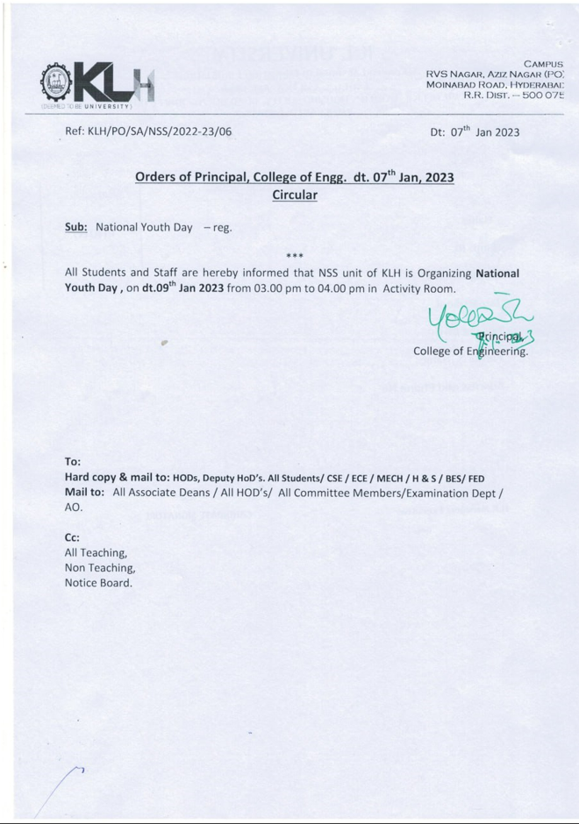

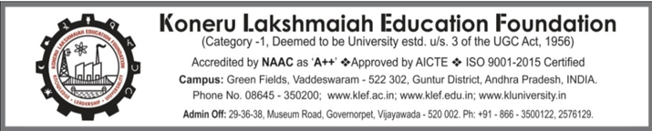

**NATIONAL YOUTH DAY-2023**

**Date of Event: 09-01-2023**

**Time: 3:00 -3:50 pm**

**Location of Event: Activity Room**

**Number of Persons Attending: 50**

**Faculty Coordinator:** **Dr. Mardanpally Mallesh**

**CONDUCTED BY: National Service Scheme**

Today on 09 January 2023 National Youth Day program was held on the occasion of **Swami Vivekananda’s** birthday and it was successful. Many Students from both Y21 and Y22 joined this event. This shows the active participation of the KLH team. All worked jointly to make this environment green and it was victorious.

The event started at 3:00 pm. **Mr. CH.S.V. Krishna**- Assistant Commissioner of Police-CAR, Headquarters, Cyberabad was invited as the event’s chief guest. The event started by addressing the guests. Next Dr. M.P. Mallesh program officer of the NSS KLH unit addressed the gathering and invited the guest to speak a few words.

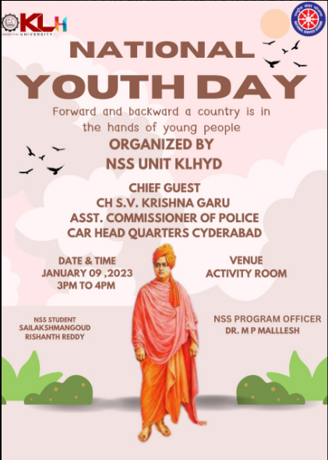

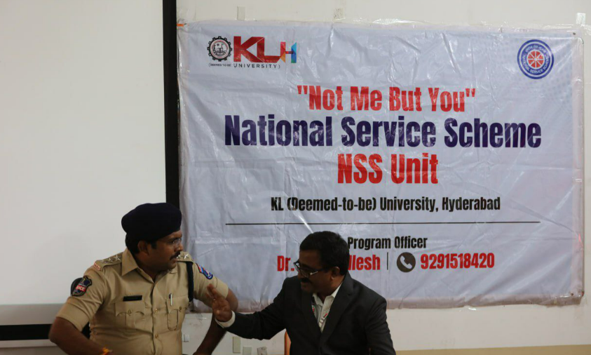

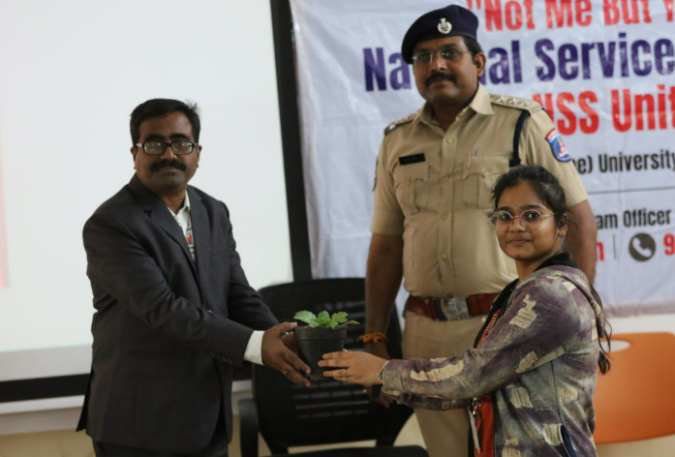

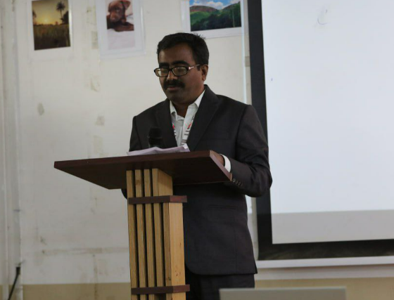

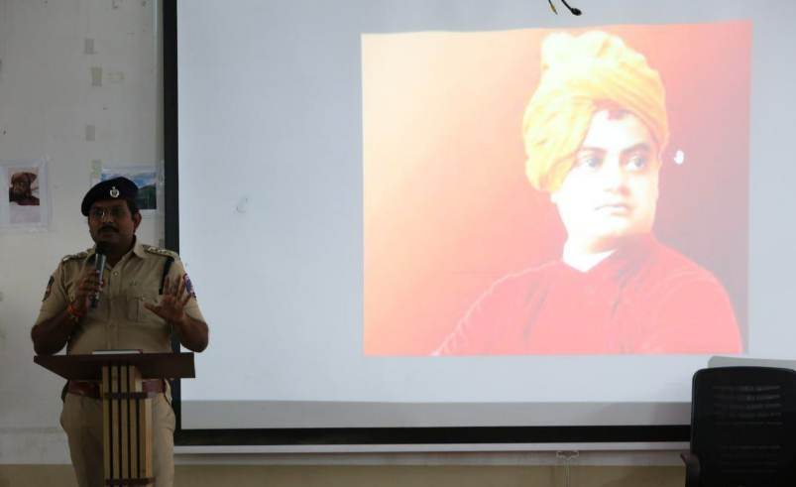

Mr. CH.S.V. Krishna motivated the gathering by letting them know about the greatness of Swami Vivekananda and also what situations are happening in society. About how one should not get into bad things like drugs, smoking, etc. How we should help others and be kind.

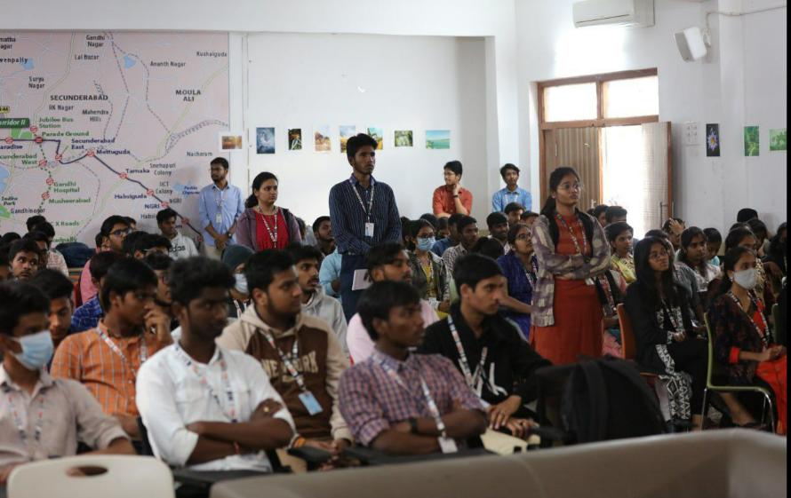

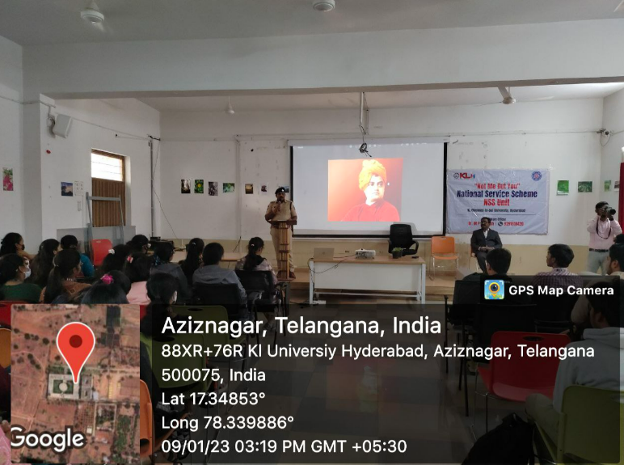

Our chief guest was felicitated with a shawl and memo. The whole event gave us good exposure to how our surroundings should be. Everyone came as one to make this event successful and victorious.

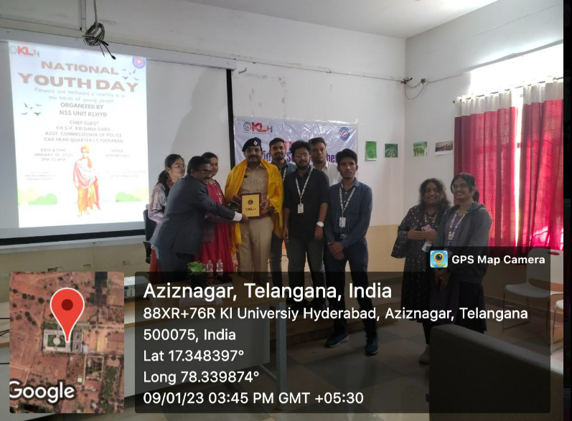

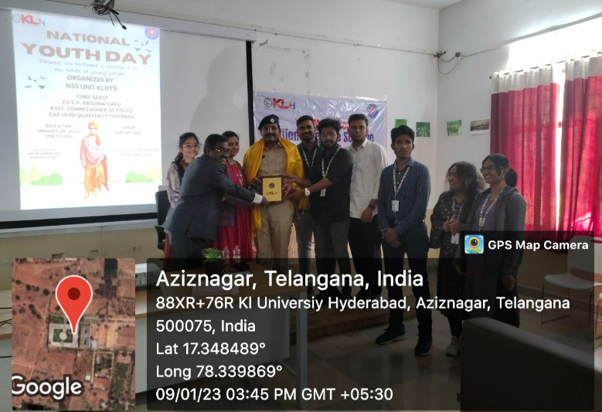

STUDENTS PARTICIPATION LIST

